DT-55
Vertical Machining Center
Technical specification
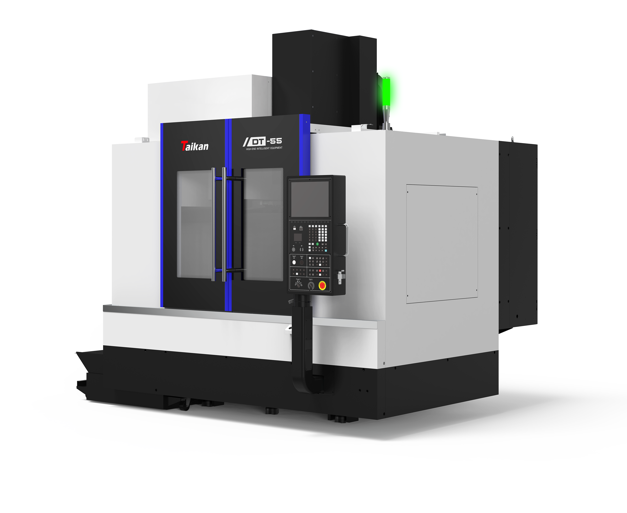
- Technical description of equipment
DT-55 vertical machining center is a small and medium-sized machine tool. The work-piece can automatically and continuously complete milling, drilling, boring, expanding, reaming, countersinking, tapping and other processes after one clamping. The machine tool is suitable for processing various types of small and medium-sized batches of complex parts such boxes, plates, plates, valves, shells, molds, etc. The machine tool adopts high-precision linear guideways and screws. The machine has better dynamic response and can achieve high-speed cutting without creeping at low speed. It is widely used in precision parts, 5G products, hardware, auto parts, and medical equipment industries.
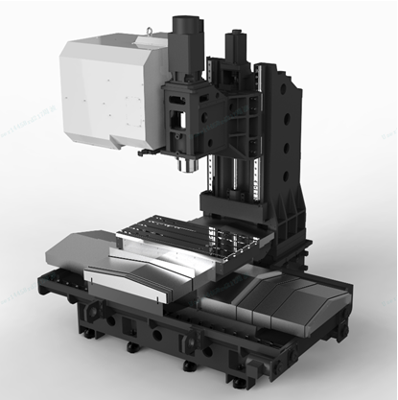
- The T-shaped bed structure design is adopted, with the saddle moving left and right on the X-axis, and the workbench moving forward and backward on the Y-axis. The full stroke support structure of the workbench and sliding seat solves the problem of left and right suspension of the traditional C-type vertical machining center workbench, achieving optimal dynamic performance and cutting stability.
- The spindle adopts a precision high-speed spindle unit BBT40-12000r/min directly connected spindle with cooling, reducing thermal deformation of the spindle, improving machining accuracy of the spindle, and delaying the service life of the spindle bearings. The front end of the spindle adopts a maze design, and the spindle is equipped with an air curtain protection function to prevent cutting fluid from entering the spindle bearings.
- The entire machine is fully enclosed and protected, with a simple, elegant, and beautiful design. Convenient operation and maintenance.
- The large diameter precision ball screw adopts a hollow cooling and pre drawn structure, reducing the thermal deformation of the screw, improving processing accuracy and stability, and extending the service life of the screw.
- Configure a volumetric and forced lubrication grease system. Lubricating grease has higher load-bearing capacity and better damping and shock-absorbing ability. It has a small creep tendency and is not easy to lose. Even under high-speed centrifugal force, it is not easy to throw out, has a long service life, low evaporation, reduces the number of oil applications, and is energy-saving and environmentally friendly.
- Adopting built-in double spiral chip removal and a large capacity water tank on the left, it improves the chip removal efficiency of the machine tool, reduces maintenance time, and improves production efficiency.
- Fully enclosed tool magazine, protecting and maintaining clean and tidy tools, reducing the splashing of machining iron filings into the tool magazine. Using servo motors to control ATC tool change speed and angle, improving tool change speed and stability, and improving machining efficiency.
- Configure the Genesis GSOS Pro intelligent CNC operating system, customize the shortcut function interface, and operate more quickly. The standard Top surface with excellent curved surface can effectively improve the quality and efficiency of mold processing. Electronic key entry system, advanced encryption technology, and identity verification machine for higher security.
- Basic parameters
Name |  |  | Unit | Parameter | Remarks
Travel | Worktable travel(X-axis) |  | mm | 1050
Travel | Saddle travel(Y-axis) |  | mm | 550
Travel | Spindle box travel (Z-axis) |  | mm | 550
Travel | Distance from spindle nose to worktable surface |  | mm | 120-670
Travel | Distance spindle center to column guide surface |  | mm | 650
Worktable | Worktable size |  | mm | 1200*500
Worktable | Worktable loading |  | kg | 800
Worktable | T-SLOT(QTY-Width*Space) |  | mm | 5-18*100
Spindle | Motor power (S1/S6) |  | kW | 11/18.5
Spindle | Motor torque (S1/S6) |  | Nm | 52.5/118
Spindle | Rotary speed |  | r/min | 50∼12000（direct）
Spindle | Spindle diameter |  | mm | Ф150
Spindle | Spindle tapper |  | / | BBT40
Drive | Motor power X/Y/Z |  | kW | 3.0/3.0/3.0 | β Motor
Speed | X/Y/Z axis rapid speed |  | m/min | 48/48/48
Accuracy | Position accuracy(X/Y/Z) |  | mm | 0.006/0.006/0.006 | VDI 3441
Accuracy | Repeatability(X/Y/Z) |  | mm | 0.004/0.004/0.004 | VDI 3441
Tool magazine | Tool capacity |  | T | 30
Tool magazine | Max. weight |  | kg | 8
Tool magazine | Max. length |  | mm | 350
Tool magazine | Max. allowable torque |  | Nm | ≤10.19
Tool magazine | Max. diameter(full/adjacent) |  | mm | Ф80/Ф150
Others | CNC system |  | / | FANUC 0i MF PLUS(5)
Others | Gas source | Flow | L/min | ≥280（ANR）
Others | Gas source | Air pressure | MPa | 0.6-0.8
Others | Equipment capacity |  | KVA | 25
Others | Machinery size |  | mm | 3148*2926*2935 | Corresponding X*Y*Z axis
Others | Machine weight (approx.) |  | Kg | 6000
#: The overall dimensions of the machine tool may change due to configuration without further notice.

- Standard configuration
- Main configuration
No. | Name and specification | Quantity | Remarks
1 | Cast iron machine bed | 1
2 | FANUC 0i MF PLUS(5) CNC system | 1
3 | Three-axis roller guideways | 1
4 | NSK high-speed screw(with hollow cooling) | 1
5 | BBT40-12000rpm direct spindle | 1
6 | Operation panel | 1
7 | 30T disc type tool magazine | 1
8 | Automatic lubrication system | 1
9 | Water cooler(spindle/screw) | 1
10 | Tool cutting cooling system | 1
11 | Pneumatic system | 1
12 | Full enclosed cover | 1
13 | LED working light | 1
14 | Tricolor warning light | 1
15 | Hand wheel | 1
16 | Three-axis internal protection | 1
17 | Air gun | 1
18 | Double spiral chip removal | 1
19 | Safety door lock | 1
20 | Tool box and tools | 1
21 | Machinery manual | 1

- Optional configuration
No. | Name and specification | Quantity | Choose | Remarks
1 | FANUC 0i MF PLUS(1) CNC system | 1 | √

Note: If this configuration is selected, mark √ in the corresponding item box.

- Brand of main part
No. | Name and specification | Brand | Remarks
1 | Control system | FANUC
2 | Spindle unit | Genesis
3 | Tool magazine | Genesis
4 | Ball screw | NSK | Japan
5 | Screw bearing | NSK | Japan
6 | Linear guideways | THK | Japan
7 | Main pneumatic system | SMC | Japan
8 | Spindle cooler | Genesis
9 | Coupler | NBK/KTR | Japan/German
10 | Main electrical component | Schneider | France

- Working conditions and environment
1. Precautions: This machine tool should be placed away from the following places:
1.1. Direct sunlight, near heat sources and environments with large temperature changes.
1.2. High humidity environment.
1.3. Too much dust environment.
1.4. Environment with vibration sources nearby.
1.5. Environment with too soft foundation.
2. Working environment requirements (environmental conditions for stable operation of machine tools):
2.1. Ambient temperature: 5~40℃
2.2. Relative humidity: ≤75%
2.3. Power supply: 3AC380V±5%, 50Hz±1%
2.4. Air medium: non-corrosive medium
3. Environmental conditions for accuracy assurance:
3.1. The machine tool must be installed on an independent foundation and away from vibration sources.
3.2. The ambient temperature is maintained between 22±1℃
3.3. The temperature change within 30 minutes is ≤1℃
3.4. The relative humidity is ≤75%
3.5. The dust particle density is ≤0.3 mg/m3
4. Requirements for air pressure source:
4.1. The air pressure is required to be 0.6~0.8 MPa.
4.2. The air flow provided by the compressor: 280 L/min (ANR) does not contain workpiece chips.
4.3. Dew point temperature: below -17℃ or lower (atmospheric pressure environment).
4.4. The air is required to be clean, with less moisture and oil mist. Do not use the compressor to directly supply air to the machine tool through a short pipe. High-temperature air will make the oil viscous when the machine is cooled, clogging the valves and pipes, causing rust and burning the spindle bearings.
4.5. When there is a lot of moisture in the air, use a desiccant or other auxiliary devices.
5. Coolant requirements:
5.1. The coolant must be water-soluble.
5.2. The coolant must be chemically stable and have lubricating properties.
5.3. Ensure that the coolant is not toxic to the human body.
5.4. Ensure that the coolant does not harden or swell items made of rubber and resin.
5.5. Use low-foaming coolant.

